**LOAD CELL AND FSR BASED HAND ASSISTIVE DEVICE**

*A Graduate Project Report submitted to MAHE in partial fulfilment of the requirement for the award of the degree of*

**BACHELOR OF TECHNOLOGY**

**In**

**Instrumentation and Control Engineering**

*Submitted by*

**RAMY SOLANKI(140921400)**

**ROHAN SHEKHAR(140921332)**

*Under the guidance of*

**Mr.Aneesha Aacharya**

**Assistant professor,**I & CE

M.I.T, MANIPAL

**May 2018**

Manipal

< Date >

**CERTIFICATE**

This is to certify that the project titled **LOAD CELL AND FSR BASED HAND ASSISTIVE DEVICE** is a record of the bonafide work done by **ROHAN SHEKHAR** (140921332) and **RAMY YOGESHKUMAR SOLANKI(**140921400)submitted in partial fulfilment of the requirements for the award of the Degree of Bachelor of Technology (B.Tech) in **INSTRUMENTATION AND CONTROL ENGINEERING** of Manipal Institute of Technology Manipal, Karnataka, (A Constituent unit of MAHE, Manipal), during the academic year 2018-19.

|  |  |
| --- | --- |
| **Dept Guide Name**  **Mr.Aneesha Aacharya**  **Assistant professor,**I & CE  M.I.T, MANIPAL | **Prof. Dr. DayanandaNayak**  *HOD, I & CE.*  *M.I.T, MANIPAL* |

**ACKNOWLEDGMENTS**

It is our privilege to express our sincerest regards to our director, Dr Srikanth Rao for providing us with all the necessary facilities for carrying out the project.

We deeply express our sincere thanks to our head of department, Dr Dayananda Nayak for encouraging us to present the project on the topic “Load cell and FSR based hand assistive device” at our department premises for the partial fulfilment of the requirements leading to the award of B-Tech degree.

We are also grateful to our project guide Mr Aneesha Acharya, for his valuable inputs, able guidance, encouragement, whole hearted corporation and constructive criticism throughout our project.

We would like to appreciate the guidance given by other supervisor as well as panels especially in our project presentation that has improved our presentation skills by their comments and tips.

We respect and thank all the laboratory in charge and staff members of Instrumentation and Control Engineering Department for their inestimable guidance and valuable information from their respective fields.

We pay our respects and love to our parents and all other family members and friends for their love and encouragement throughout our career.

**ABSTRACT**

Hand disability in today’s world is one of the most common problem because of hand disability the person freedom of actions are restricted which means that the person is not able to move his/her hand freely. The hand disability is caused by the head injury, strokes etc. Strokes lead to weakening to hand muscles because of which the patient is not able to hold the object properly. These types of problem are treated by physical therapy and its recovery is monitored by the devices such as load cell and FSR sensor.

In this project load cell and FSR sensors are used for monitoring the patient recovery. The load cell and the FSR sensors are connected to the Arduino Uno and Nano respectively. Here the patient are asked to apply the force on both these devices on by one and the values of these forces are recorded in the pc with the help of PLX-DAQ software.

After collecting the data in computer with the help of PLX-DAQ then these data are transferred to the software which is rapid miner for getting the maximum value of the force. By determining the maximum value of the force one can infer that the patient is recovering by comparing its present and previous value in rapid miner software one can also see the graph of the force vs time which will give a clear picture of his recovery.

**LIST OF TABLES**

|  |  |  |
| --- | --- | --- |
| **Table No** | **Table Title** | **Page No** |
| 3.7 | **load cell specification** |  |
| 3.8 | **Arduino uno specification** |  |
| 3.9 | **FSR specification** |  |
| 3.10 | **HX711 specification** |  |
| 3.11 | **Arduino nano specification** |  |
| 3.12 | **HC-05 specification** |  |

**LIST OF FIGURES**

|  |  |  |
| --- | --- | --- |
| **Figure No** | **Figure Title** | **Page No** |
| 3.1 | **Block diagram of setup** |  |
| 3.2 | **Load cell calibration** |  |
| 3.3 | **Load cell setup** |  |
| 3.4 | **Loadcell interface with amplifier and Arduino** |  |
| 3.5 | **FSR interface with Arduino** |  |
| 3.6 | **FSR Mode** |  |
| 4.1 | **Block diagram of rapid miner** |  |
| 4.2 | **Data of load cell** |  |
| 4.3 | **Data of load cell** |  |
| 4.4 | **Graph of load cell** |  |
| 4.5 | **Maximum value of force** |  |
| 4.6 | **FSR output subject 1** |  |
| 4.7 | **FSR output subject 2** |  |
| 4.8 | **FSR graph** |  |
| 4.9 | **Maximum value of FSR** |  |
|  |  |  |

|  |  |  |  |  |  |
| --- | --- | --- | --- | --- | --- |
| **Contents** | | | | | |
|  | | | | | Page No |
| Acknowledgement | | | |  | 3 |
| Abstract | | | |  | 4 |
| List Of Figures | | | |  | 5 |
| List Of Tables | | | |  | 7 |
|  | | | | | |
| **Chapter 1** | | | **INTRODUCTION** | |  |
|  | **1.1** | Introduction | | | 9 |
|  | **1.2** | Motivation | | | 9 |
|  | **1.3** | Objective | | | 9 |
|  | **1.4** | Target Specification | | | 9 |
|  | **1.5** | Project Work Schedule | | | 10 |
|  | | | | | |
| **Chapter 2** | | | BACKGROUND THEORY and/or LITERATURE REVIEW | |  |
|  | **2.1** | Literary Review | | | 11 |
|  | | | | | |
| **Chapter 3** | | | **METHODOLOGY** | |  |
|  | **3.1** | Methodology | | | 13 |
|  | **3.2** | Circuit Layout | | | 13 |
|  | **3.3** | Calibration | | | 14 |
|  | **3.4** | Component Specification | | | 16 |
|  | **3.5** | Loadcell | | | 16 |
|  | **3.6** | Arduino Uno | | | 17 |
|  | **3.7** | FSR | | | 18 |
|  | **3.8** | Hx711 | | | 18 |
|  | **3.9** | Arduino Nano | | | 19 |
|  | **3.10** | HC-05(Bluetooth module) | | | 20 |
|  | **3.11** | Justification of components | | | 20 |
|  | **3.12** | Tools used | | | 20 |
|  | | | | | |
| **Chapter 4** | | | **RESULT ANALYSIS** | |  |
|  | **4.1** | Result analysis | | |  |
|  | **4.2** | Graphical / Tabular Form | | |  |
|  | **4.3** | Explanation for graphical / tabulated system | | |  |
|  | **4.4** | Significance of the result obtained | | |  |
|  | **4.5** | Deviation from expected results & its justification | | |  |
|  | **4.6** | Conclusion | | |  |
|  | | | | | |
| **Chapter 5** | | | **CONCLUSION AND FUTURE SCOPE** | |  |
|  | **5.1** | Conclusion | | |  |
|  | **5.2** | Future Scope | | |  |
|  | | | | | |
| **REFERENCES** | | | | |  |
| **ANNEXURES (OPTIONAL)** | | | | |  |
| **PROJECT DETAILS** | | | | |  |

**CHAPTER 1**

**INTRODUCTION**

Human interaction can be restricted due to the limitation of freedom of action. One of the most common problems in today’s world is the hand disability. As hand plays a major role in eating, grasping and writing etc. the malfunctioning of the hand may be caused due to head injury, strokes etc. Another factor which leads to hand disability is stroke. Strokes usually lead to weakness of specific muscles and related movement deficits. The complication of these diseases can be treated by surgery or physical therapy. The recovery of the hand is essential in improving the quality of life, even though not perfectly normal. Most commonly the hand grip strength is used to determine the performance of forehand muscles. The test is usually carried out by a strain gauge which determines the grip strength of the person. This project helps to determine the grip strength of a hand disabled person in order to compare the present and previous results and see the improvement in the person. In this project the strain gauge helps in obtaining the data which is displayed on the computer.

In this project FSR sensor is also required which is used to determine the net force that the person will be applying on the FSR sensor which is kept at the circumference of the can bottle. The FSR sensor is attached to Arduino Nano which is kept inside the can and the data will be transferred to the computer with the help of a Bluetooth module.

**MOTIVATION**

In order to evaluate the successfulness of each treatment, a hand grip assessment tool is practically needed. This tool particularly helps in monitoring the process of recovery thoroughly. It quantifies the patient performance as it measures the exertion of force that acts on it.

**OBJECTIVE**

The objective of the project is to record the force from the load cell and FSR (Force Sensing Resistor) sensor and transmit the data through Bluetooth module to the computer.

**TARGET SPECIFICATION**

In this project the person has to hold the load cell at the centre of his hand and press it so that the data will be acquired in the computer. The person has to hold the load cell in his hand for a period of 5 sec in order to get the final result. But in the case of the FSR sensor the person has to apply the force on the FSR sensor where each FSR sensor will be having its own force value than those force value will be added and then displayed on the computer monitor. The graph of the result will be plotted and will be compared with the previous value.

**PROJECT WORK SCHEDULE**

* **JANUARY:** status-completed

Learning basics of Arduino

* **FEBRUARY:** status-completed

Configured load cell with Arduino

Load cell output obtained in pc

Configured FSR sensor with Arduino

FSR output obtained in pc

* **MARCH:** status-completed

Wireless transmission of data for load cell and FSR sensor

Collected the data in excel sheet

Plotted the graph

* **APRIL :** status-completed

Storing the data in rapid miner

Making database in rapid miner

Querying the data in rapid miner

Completion of FSR and load cell model

* **MAY:** status-completed

Documentation and presentation

**CHAPTER 2**

**BACKGROUND THEORY**

**LITERATURE REVIEW**

The impact of disability on society is great not only on direct treatment costs. Invaluable loss of human creative activity and mental wellbeing as well as productivity losses reflect the indirect impact on the disabled individual as well as on society as a whole. Stroke is the leading cause of disability in the industrialised countries. Every year, over 130,000 people in the U.K. suffer strokes, with 13,000 under retirement age. Ischemia or haemorrhage in the brain may be the cause of cerebral vascular accidents which result in strokes (Parker et al., 1986). Fortunately over 65% of patients survive but the majority does have residual disabilities with up to 1/3 having severe disabilities particularly in the upper limb and hand. Hemiplegia, the most common impairment resulting from stroke, leaves the survivor with a stronger unimpaired arm and a weaker impaired one (hemiparesis). Traumatic injuries as well as conditions like muscular dystrophy, arthritis and regional pain syndromes, also add to the major causes of disability and functional dependence. Deficits in motor control and coordination synergy patterns, spasticity and pain are some of the most common symptoms of these conditions (Parker et al., 1986).

To meet the hand grip strength analysis requirements, the sensory unit modeling can be done in two approaches. The first is the Loadcell approach wherein a patient is made to hold a loadcell and apply full strength on the grip structure. The second approach is to use an FSR on a cylindrical object. The main advantage of using a loadcell is that the highest value of grip strength is calculated and the entire grip strength including the palm and the fingers is calculated unlike FSR where only finger strength is calculated. The loadcell setup consists of a strain gauge and a Wheatstone bridge. The Loadcell setup for hand therapy is more popular as it gives a wider area for application of force. The interest in this paper is to model a similar FSR model and to use it with a wireless Bluetooth module unlike the old setup in which data is stored from loadcell in a DAQ setup using an SD card for portable use.

The data is obtained and stored in Excel to allow flexible analytics. The patient is asked to hold the setup in a comfortable position and apply the maximum possible strength. The patient’s dominant and non-dominant hand is known simply by asking. Then the readings of both the arms are obtained and the average percentage difference is calculated. Various cases are observed, and it is noted that an error of is observed by ASHT (American Society of Hand Therapy) which states that a difference of 10% approximately is observed when evaluating the difference percentage approximately. The 10% rule is of force of a dominant and a non-dominant arm. Overall, every device has its respective approach to treat the patient. However, the core aim is to obtain back the basic function of the hand. In order to evaluate the successfulness of each treatment, a hand grip assessment tool is practically needed.

Our work was an extension of a research which generated reference values for muscle force obtained with a hand-held dynamometer and specific testing procedures. Consistent with a considerable volume of research already published, gender, age, and weight were shown statistically to influence force measures. Consequently, reference information was reported in two forms. The first form involved regression equations. The multiple correlations associated with the equations compare favorably to those reported by other researcher who used different instrumentation.

## Although separate values for the dominant and non-dominant sides are probably not essential for lower extremity actions (given the nonsignificant differences in force for specific muscle actions between sides), they are provided for those clinicians who wish to use them. The normative values are reported in both a normalized (against body weight) and non-normalized format. The mean values, when demarcated by two standard deviations, provide a reasonable estimate of normal that can be used for judgments about force impairments. Any value that is less than two standard deviations below the mean value, therefore, can be considered a below normal force measure.

Another study showed analysis of the measures for isometric handgrip strength of fingers showed excellent test-retest reliability and construct validity for the load cell handle specially developed for this study, both for individuals with of upper limb and hand dysfunctions and for healthy volunteers.

Our work adds value to this research as we have added a way to tabulate quantified hand grip strength analysis by using two different types of sensors. The Rapid miner tool helps with a huge set of mathematical functions that allow a person to calculate the maximum force applied by the patient and record the data to discover the rate of recovery of a patient.

**CHAPTER 3**

**METHODOLOGY**

**METHODOLOGY**

In Fig3.1 the development of hand dynamometer consists of hardware and software unit. The hardware consists of main unit and sensory unit. The voltage displacement obtained from strain gauges bonded on the bending beam is measured using a full-bridge Wheatstone configuration. This storage will be amplified using an instrumentation amplifier which will be connected to a microcontroller like Arduino and then to a personal computer.

The sensory unit consists of the load cell which is used to sense the data and give it to the Wheatstone bridge. This is the transducer element where the person with despaired hand applies pressure on the dynamometer and the output is obtained. With repeated practice after obtaining a lot of data over a period of time, data analysis is done to obtain the amount of improvement that the patient has undergone. The main unit is used to obtain command signals from the transducer, to amplify the signals and to send it to the personal computer using an Arduino Uno. The main unit consists of three components, the Wheatstone bridge, the amplifier and a microcontroller. The Wheatstone bridge obtains the small voltage which is amplified by the amplifier and transferred to the pc using Arduino.

The transmission unit consists of a Bluetooth module which is used to transfer the data obtained on one system remotely to some other Personal Computer. This is done by using two Bluetooth modules by making one module from which the data is transferred as the slave and the other Bluetooth module which will obtain the data as the Master. Tera Term software is used to configure the Master Bluetooth module.

**CIRCUIT LAYOUT**

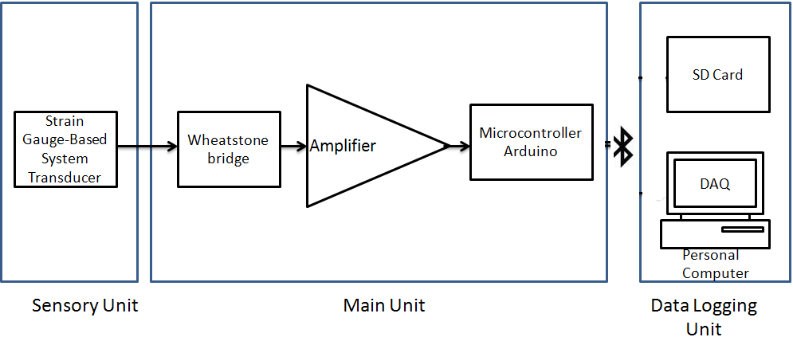

**Fig3.1: Block diagram of setup**

**CALIBRATION**

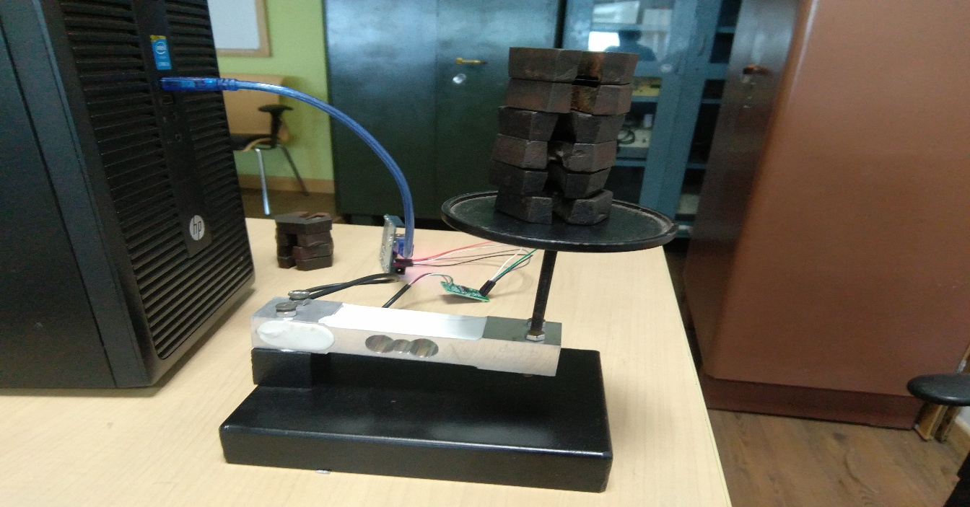

**Fig3.2: Load cell calibration setup**

In fig 3.2, equal weights are added one after the other on the loadcell calibration setup . When the weights are being put on the load cell it will give certain reading for a specific weight in grams. The up and down readings should match with one another. So that one can infer that the device will work correctly for any amount of force applied. Since it is a 40 kg load cell we should not apply more than 40 kg of weight, otherwise it will be out of range.

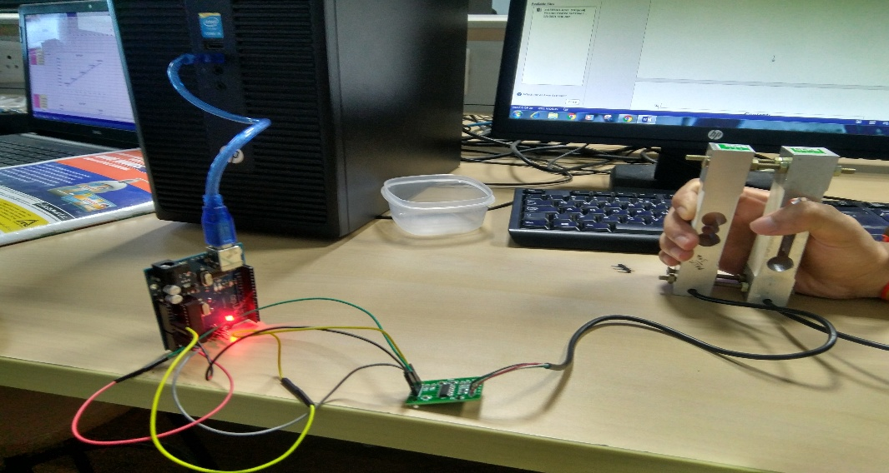

**Fig3.3: Load cell setup**

Fig1.3 shows the load cell setup which consists of a 40 kg load cell and a non-functional load cell which acts as a handle for support.it should be held in the same way as shown in the figure.

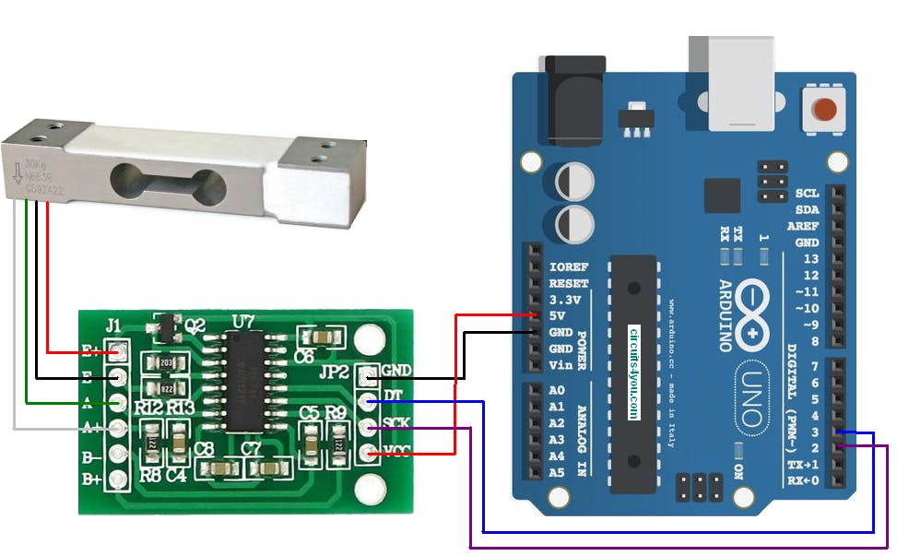

**Fig3.4: Loadcell interface with amplifier and Arduino**

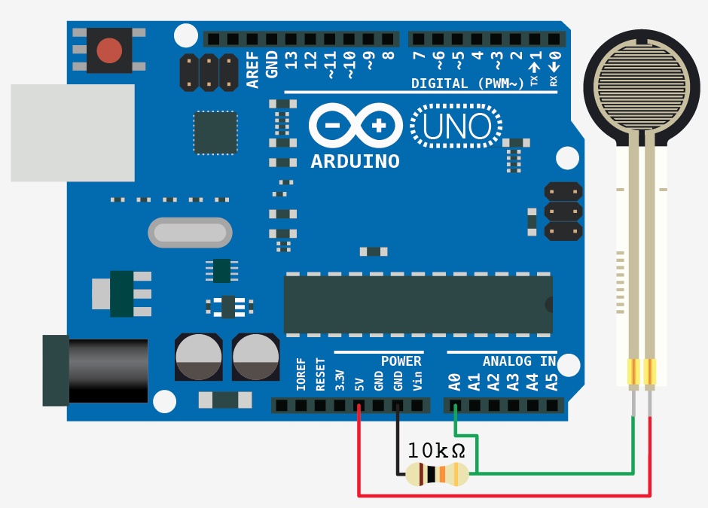

**Fig3.5:FSR interface with Arduino**

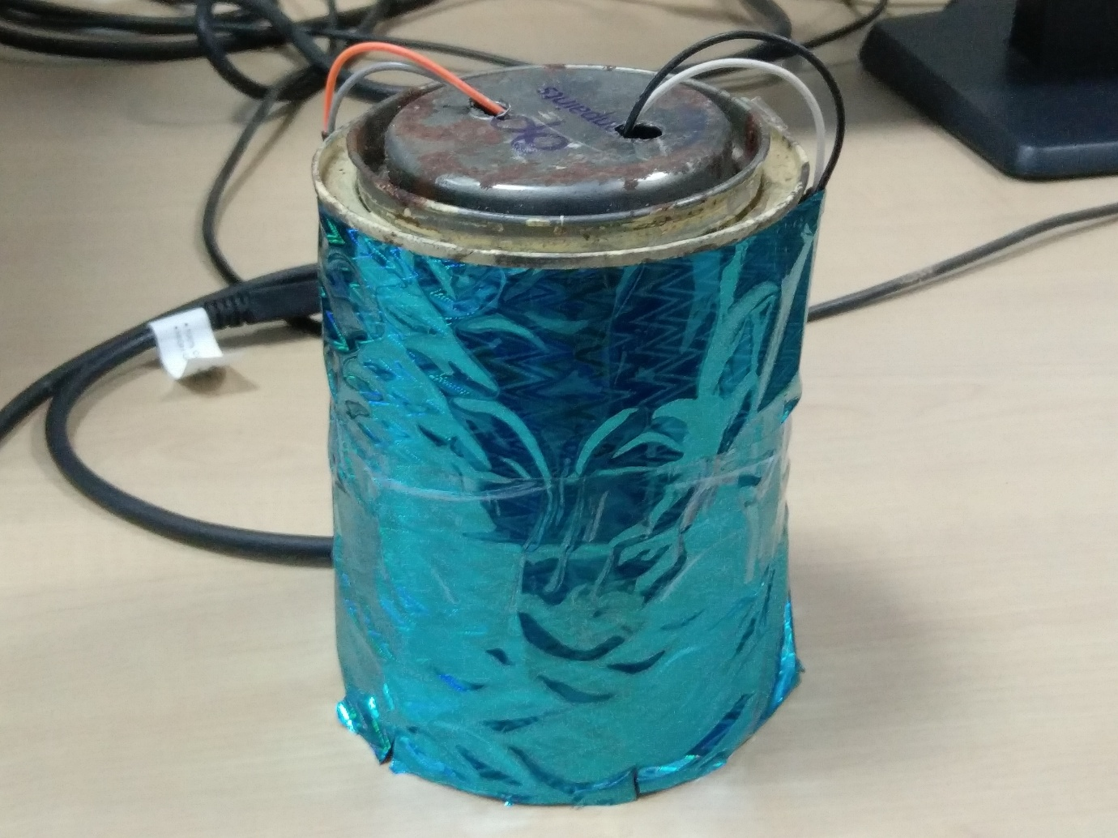

**Fig3.6:FSR Model**

In the fig3.6 shown above is the model of a FSR sensor which is used for monitoring the patient recovery. When the patient applies the force on the cylindrical object which consists of FSR sensor at the circumference it gives the value of the force in newton’s which is recorded in the pc and is compared with the previous values of the patient to see whether the patient has recovered.

**COMPONENT SPECIFICATION**

**LOAD CELL-**

|  |  |
| --- | --- |
| **Parameter** | **Value** |
| Type | Single Point Load Cell |
| Total Precision | C3 class |
| Material | Aluminum Alloy |
| Surface | Anodized Treatment |
| Protection | IP65 |
| Suggested Platform Size | 350 x 350 mm |
| Applications | Weighing Scales, Retail, Bench & Counting Scales |
| Rated Load | 40 Kg. Max |
| Rated Output | 2.0mV/V+/- 5% |
| Zero Balance | +/- 1% Full Scale |
| Input Resistance | 405 +/- 6 Ohm |
| Output Resistance | 350 +/- 3 Ohm |
| Excitation Voltage | 5-12V DC |
| Nonlinearity | 0.017% Full Scale |
| Hysteresis | 0.02% Full Scale |
| Repeatblity | 0.01% Full Scale |
| Creep(30min) | 0.015% Full Scale |
| Operating Temperature | -20 °C to +65 °C |
| Temperature Effect on Zero | 0.017% Full Scale / 10 °C |
| Temperature Effect on Span | 0.014% Full Scale / 10 °C |
| Insulation Resistance | 5000 Mega Ohm(50V DC) |
| Safe Overload | 150% Full Scale |
| Ultimate Overload | 200% Full Scale |
| Cable | 420mm(3mm dia 4 wire shielding cable) |

**Fig3.7:load cell specification**

**ARDUINO UNO**

|  |
| --- |
| **C:\Users\Mahe\Desktop\2.PNG** |

|  |  |
| --- | --- |
| C:\Users\Mahe\Desktop\2.PNG |  |

**Fig3.8:Arduino uno specification**

**FSR-**

|  |
| --- |
| C:\Users\Mahe\Desktop\Capture4.PNG |

**Fig3.9:FSR specification**

**Hx711**

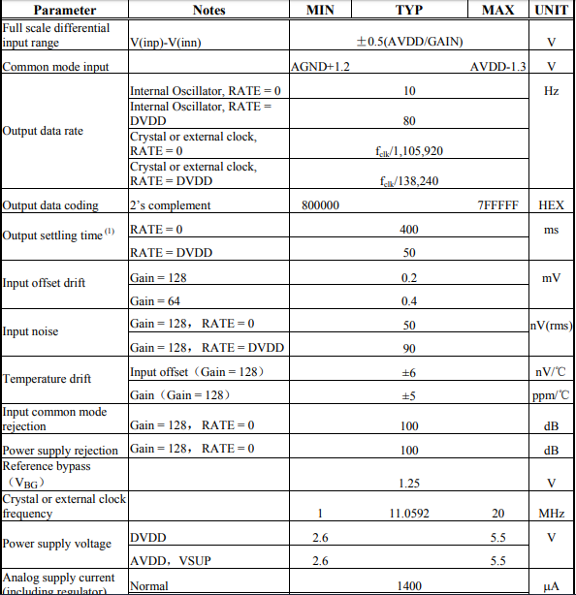

**Fig3.10:HX711 specification**

**ARDUINO NANO**

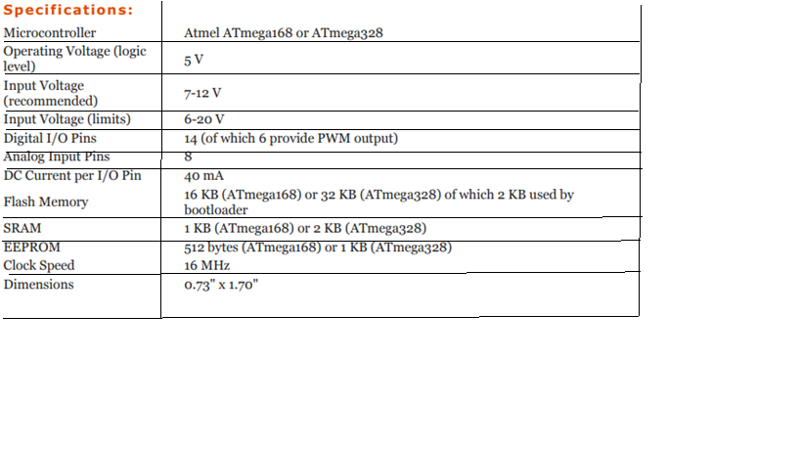**Fig3.11:Arduino nano specification**

**HC-05(Bluetooth module)**

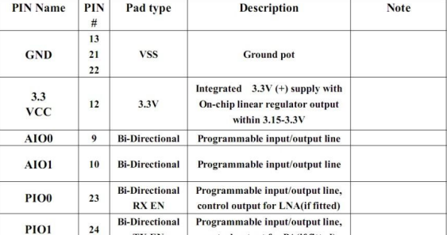

**Fig3.12:HC-05 specification**

**JUSTIFICATION OF COMPONENT-**

The component which is used in our project are load cell and FSR. Since our project is based on hand rehabilitation therefore load cell and FSR are the ideal device. In our project these two device helps us to determine the force applied by the patient by which one can determine patient recovery. The recovery of the patient can be determined by comparing the present and previous result of the force.

**TOOLS USED-**

* Bread board
* Battery
* Connecting wires
* Arduino Nano board
* Resistors
* Load cell
* Rx-711 amplifier
* FSR sensor
* Arduino software
* Tera term software
* Plx daq software
* Ms excel
* Rapid miner software

**CHAPTER 4**

**RESULT ANALYSIS**

In this chapter, the data analytics of the force is done using Rapid Miner Studio.Rapid Minor is a data mining tool which is freely available on the internet. The force obtained from Loadcell and FSR sensor via Arduino is stored in Ms Excel.

The data from Ms Excel is stored in Rapid Miner and the graphs are plotted by the data. The block diagram that was built on Rapid minor is used to obtain the maximum value of a data set of force. The block diagram obtains the maximum value of force obtained by 2 subjects.

**Result analysis**

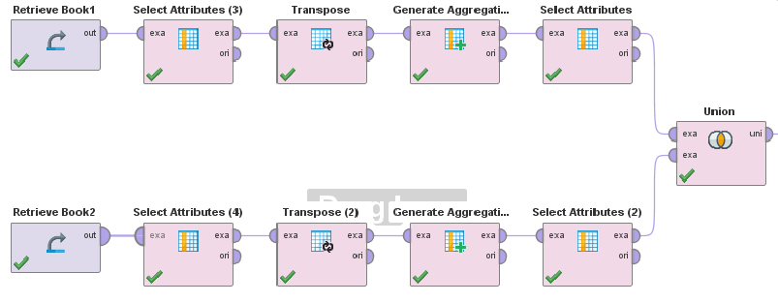

**Fig4.1:Block diagram of rapid miner**

**Graphical / tabular form**

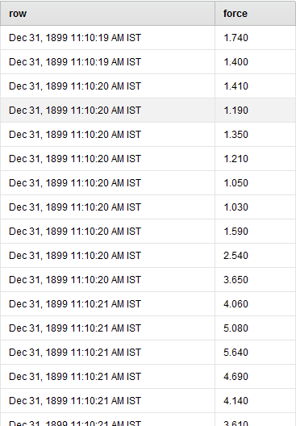

**Fig4.2: Data of load cell**

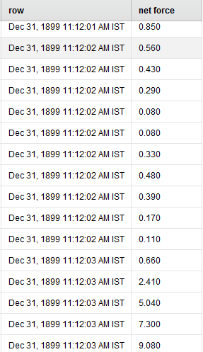

**Fig4.3: Data of load cell**

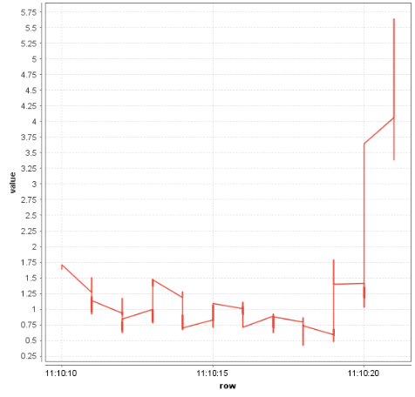

**Fig4.4: Graph of load cell**

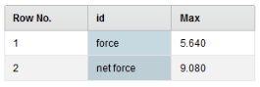

**Fig4.5: Maximum value of force**

**Explanation for the graphical / tabulated results**

In the table, the force values obtained by loadcell/Fsr is stored and the graph is also stored in GUI.

The block diagram used saves the highest value of the force.

In the Rapid Miner GUI, the retrieve block obtains the data from excel. Then the Select Attribute block is used to obtain only those attributes which are needed. The unnecessary attribute is selected and the reverse selection check box is checked. So only the useful attributes are selected. Then the transpose block is used which displays the table in transpose. Then in the generate attributes block the maximum value of all the data is stored under the MAX sub column. After that in the SELECT ATTRIBUTES block we select only the MAX sub column and it is displayed in the UNION function

FSR Sensor based

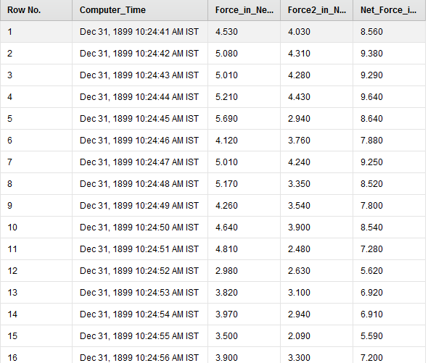

**Fig4.6: FSR output subject 1**

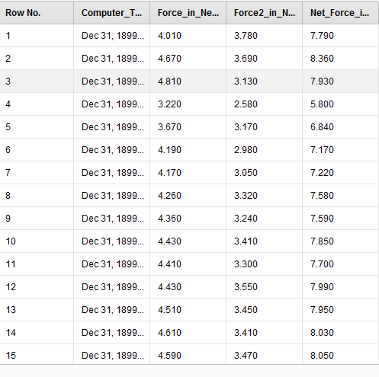

**Fig4.7: FSR output subject 2**

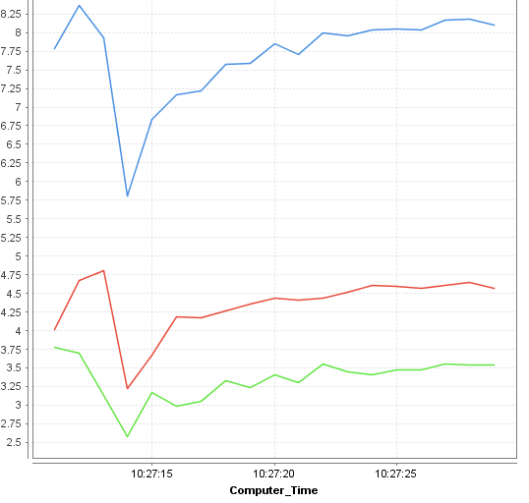

**Fig4.8: FSR graph**

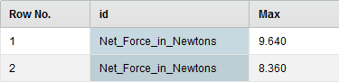

**Fig4.9: Maximum value of FSR**

**Significance of the result obtained**

The highest values of force that is obtained by subjects is analysed over a period of time. The highest value is checked and if it increases, then it is a sign of improvement.

As the value increases it signifies an improvement in the hand grip strength which is the core purpose of this project.

**Deviations from the expected results & its justification**

The deviation that might be encountered while taking readings might not be always increasing linearly. The readings can increase non-linearly also. In some cases, it can be that patients might have small chucks of periods for constant force readings. Then it might increase slowly. This implies that the improvement in hand grip strength takes place slowly. But if we obtain readings that are constant for a long period of time then we can infer that there is no improvement in hand grip strength.

**CONCLUSIONS**

The results that are obtain will help doctors to save hand grip strength values accurately and will also allow them to save a lot of data for different subjects easily over a period of time. The Rapid Miner Studio used can give medical professionals the ease and flexibility to plot the data in different types of graphs. The GUI which is used is very flexible.

**CHAPTER 5**

**CONCLUSION AND FUTURE SCOPE OF WORK**

In this project load cell and the FSR are being used hand rehabilitation monitoring. This project helps us to determine the patient recovery with the help of this devices. Firstly the load cell is connected to the Arduino and the code is installed in it with the help of the Arduino software. After uploading the code the patient is asked to hold the load cell and apply the force on it. After the force is applied the value of the force is recorded in the pc with the help of PLX-DAQ software. Similarly this process is repeated for the FSR sensor but here the force is applied on the cylindrical object which consists of FSR sensor at its circumference and again the force values are recorded in the pc with the help of PLX- DAQ.After the collection of data from these devices the data are sent to the rapid miner software where we determine the maximum values of force applied. Thus the maximum value of force helps us to determine patient recovery.

**CONCLUSION**

The study is a success as the objectives are met and the device can be operated wirelessly. Furthermore, the hand dynamometer is believed to be useful for force measurements for numerous ergonomics applications. The finger forces exerted when controlling and maintaining to activate the tool can be determined as a sum into the finger force measurement. In the FSR sensor we are able to obtain real time force values of the patient which can help the patient to get the output in a shorter interval of time unlike load cell.

Despite its functionality, these devices is also simple from its structure to the overall mechanism. Hence, the total cost of it is very low as compared to the price range in the current market. In fact, it may provide a huge contribution to the patient that wanted to regain their hand function all over again. Nevertheless, it still requires some improvements and modifications in order to produce a better alternative to the existing hand rehabilitation devices in the market today.

**FUTURE SCOPE**

The device which are being used in this project are load cell and FSR sensors which can be used to test the patient recovery in the future. The force values will be taken and will be stored in the pc, these values will be compared with the previous values and will be tested for the patient recovery.

The readings of load cell and the FSR can be compared with the readings of hand Jamar dynamometer in future thus it will give a better picture of recovery for the patient.

**TECHNICAL REFERENCES**

1. Norazmira Md Noh, Nahrizul Adib Kadri, And Juliana Usman, Development of arduino-based hand dynamometer assistive device, Journal of Mechanics in Medicine and Biology, Vol. 16, No. 3 (2016) 1650033
2. Li S, Latash ML, Yue GH, Siemionow V, Sahgal V, The effects of stroke and age on

finger interaction in multi-finger force production tasks, Clin Neurophysiol 114(9):1646–

1655, available at http://linkinghub.elsevier.com/retrieve/pii/S1388245703001640.

1. March L, Chamberlain A, Cameron I, Cumming R, Kurrle S, Finnegan T, Skinner J,

Prevention, Treatment and Rehabilitation of Fractured Neck of Femur. NSAHS, Merck

Sharp and Dohme Australia Pty Ltd, New South Wales, 1996.

1. Boadella JM, Kuijer PP, Sluiter JK, Frings-Dresen MH, Effect of self-selected handgrip

position on maximal handgrip strength, Arch Phys Med Rehabil 86(2):328–331, available

at http://www.ncbi.nlm.nih.gov/pubmed/15706562.

1. Clerke AM, Clerke JP, Adams RD, Effects of hand shape on maximal isometric grip

strength and its reliability in teenagers, J Hand Ther 18(1):19–29, available at http://

www.ncbi.nlm.nih.gov/pubmed/15674783.

1. Peters MJH et al., Revised normative values for grip strength with the Jamar dynamometer, J Peripher Nerv Syst 16(1):47–50, 2011, available at http://www.ncbi.nlm.

nih.gov/pubmed/21504502.

7. Wimer B, Dong RG, Welcome DE, Warren C, McDowell TW, Development of a

dynamometer for measuring grip strength applied on a cylindrical handle,

Med Eng Phys 31(6):695–704, 2009, available at http://www.ncbi.nlm.nih.gov/

pubmed/19250853.

8. Bohannon RW, Comparability of force measurements obtained with different strain

gauge hand-held dynamometers, J Orthop Sportsc Phys Ther 18:564–567, 1993.

9. Brewer BR, Klatzky R, Matsuoka Y, Visual feedback distortion in a robotic environment for hand rehabilitation, Brain Res Bull 75(6):804–813, 2008, available at http://

www.ncbi.nlm.nih.gov/pubmed/18394527.

10. Szturm T, Peters JF, Otto C, Kapadia N, Desai A, Task-specific rehabilitation

of finger-hand function using interactive computer gaming, Arch Phys Med

Rehabil 89(11):2213–2217, 2008, available at http://www.ncbi.nlm.nih.gov/

pubmed/18996252

**ANNEXURES**

**Code for load cell-**

#define DT A0

#define SCK A1

#define sw 2

long sample=0;

float val=0;

long count=0;

unsigned long readCount(void)

{

unsigned long Count;

unsigned char i;

pinMode(DT, OUTPUT);

digitalWrite(DT,HIGH);

digitalWrite(SCK,LOW);

Count=0;

pinMode(DT, INPUT);

while(digitalRead(DT));

for (i=0;i<24;i++)

{

digitalWrite(SCK,HIGH);

Count=Count<<1;

digitalWrite(SCK,LOW);

if(digitalRead(DT))

Count++;

}

digitalWrite(SCK,HIGH);

Count=Count^0x800000;

digitalWrite(SCK,LOW);

return(Count);

}

void setup()

{

Serial.begin(9600);

Serial.println("CLEARDATA");

Serial.println("LABEL,TIME,TIMER(in s),weight(in kg),");

Serial.println("RESETTIMER");

pinMode(SCK, OUTPUT);

pinMode(sw, INPUT_PULLUP);

calibrate();

}

void loop()

{

Serial.print("DATA,TIME,TIMER,");

count= readCount();

double w=((((count-sample)/val)-2*((count-sample)/val))/100);

Serial.print((double)w);

Serial.println();

delay(100);

if(digitalRead(sw)==0)

{

val=0;

sample=0;

w=0;

count=0;

calibrate();

}

}

void calibrate()

{

for(int i=0;i<100;i++)

{

count=readCount();

sample+=count;

Serial.println(count);

}

sample/=100;

Serial.print("Avg:");

Serial.println(sample);

count=0;

while(count<1000)

{

count=readCount();

count=sample-count;

Serial.println(count);

}

delay(2000);

for(int i=0;i<100;i++)

{

count=readCount();

val+=sample-count;

Serial.println(sample-count);

}

val=val/100.0;

val=val/100.0; // put here your calibrating weight

}

Code for FSR

int fsrPin = 0; // the FSR and 10K pulldown are connected to a0

int fsrReading; // the analog reading from the FSR resistor divider

int fsrVoltage; // the analog reading converted to voltage

unsigned long fsrResistance; // The voltage converted to resistance, can be very big so make "long"

unsigned long fsrConductance;

long fsrForce; // Finally, the resistance converted to force

int fsrPin2 = 1; // the FSR and 10K pulldown are connected to a1

int fsrReading2; // the analog reading from the FSR resistor divider

int fsrVoltage2; // the analog reading converted to voltage

unsigned long fsrResistance2; // The voltage converted to resistance, can be very big so make "long"

unsigned long fsrConductance2;

long fsrForce2; // Finally, the resistance converted to force

long fsrForce1;

void setup(void)

{

// open serial connection

Serial.begin(9600);

Serial.println("CLEARDATA");

Serial.println("LABEL,Computer_Time,Force_in_Newtons,Force2_in_Newtons,Net_Force_in_Newtons");

}

void loop(void) {

Serial.print("DATA,TIME,");

fsrReading = analogRead(fsrPin);

// analog voltage reading ranges from about 0 to 1023 which maps to 0V to 5V (= 5000mV)

fsrVoltage = map(fsrReading, 0, 1023, 0, 5000);

if (fsrVoltage == 0) {

} else {

// The voltage = Vcc * R / (R + FSR) where R = 10K and Vcc = 5V

// so FSR = ((Vcc - V) * R) / V yay math!

fsrResistance = 5000 - fsrVoltage; // fsrVoltage is in millivolts so 5V = 5000mV

fsrResistance *= 10000; // 10K resistor

fsrResistance /= fsrVoltage;

fsrConductance = 1000000; // we measure in micromhos so

fsrConductance /= fsrResistance;

// Use the two FSR guide graphs to approximate the force

if (fsrConductance <= 1000) {

fsrForce = fsrConductance / 80;

Serial.print(fsrForce);

Serial.print(",");

} else {

fsrForce = fsrConductance - 1000;

fsrForce /= 30;

Serial.print(fsrForce);

Serial.print(",");

fsrForce=0;

}

}

delay(500);

fsrReading2 = analogRead(fsrPin2);

// analog voltage reading ranges from about 0 to 1023 which maps to 0V to 5V (= 5000mV)

fsrVoltage2 = map(fsrReading2, 0, 1023, 0, 5000);

if (fsrVoltage2 == 0) {

}

else

{

// The voltage = Vcc * R / (R + FSR) where R = 10K and Vcc = 5V

// so FSR = ((Vcc - V) * R) / V yay math!

fsrResistance2 = 5000 - fsrVoltage2; // fsrVoltage is in millivolts so 5V = 5000mV

fsrResistance2 *= 10000; // 10K resistor

fsrResistance2 /= fsrVoltage2;

fsrConductance2 = 1000000; // we measure in micromhos so

fsrConductance2 /= fsrResistance2;

// Use the two FSR guide graphs to approximate the force

if (fsrConductance2 <= 1000) {

fsrForce2 = fsrConductance2 / 80;

Serial.print(fsrForce2);

Serial.print(",");

} else {

fsrForce2 = fsrConductance2 - 1000;

fsrForce2 /= 30;

Serial.print(fsrForce2);

Serial.print(",");

fsrForce2=0;

}

}

if(fsrForce==0 && fsrForce2==0)

{

fsrForce1=0;

Serial.print(fsrForce1);

Serial.println("");

delay(500);

}

else

{

fsrForce1=fsrForce+fsrForce2;

Serial.print(fsrForce1);

Serial.println("");

fsrForce1=0;

delay(500);

}

}

PROJECT DETAILS

|  |  |  |  |
| --- | --- | --- | --- |
| *Student Details* | | | |
| **Student Name** | **Rohan Shekhar** | | |
| Register Number | 140921332 | Section / Roll No­­­ | 23/B |
| Email Address | rohanshekharcool@gmail.com | Phone No (M) | 9591349077 |
| **Student Name** | **Ramy Yogeshkumar Solanki** | | |
| Register Number | 140921400 | Section / Roll No | 34/B |
| Email Address | ramysolanki.96@gmail.com | Phone No (M) | 8123300811 |
|  | | | |
| *Project Details* | | | |
| **Project Title** | **Load cell and FSR based hand assistive device** | | |
| Project Duration | 4 months | Date of reporting |  |
|  |  | | |
| *Organization Details* | | | |
| **Organization Name** |  | | |
| Full postal address with pin code |  | | |
| Website address |  | | |
|  |  | | |
| *Supervisor Details* | | | |
| **Supervisor Name** |  | | |
| Designation |  | | |
| Full contact address with pin code |  | | |
| Email address |  | Phone No (M) |  |
|  |  | | |
| *Internal Guide Details* | | | |
| **Faculty Name** | **Mr Aneesha Acharya** | | |
| Full contact address with pin code | Dept of Instrumentation and Control Engg, Manipal Institute of Technology, Manipal – 576 104 (Karnataka State), INDIA | | |
| Email address | Aneesha.knaarpady@gmail.com | | |